SE EXPERIMENT 8

Aim: To prepare a project schedule and project plan for the Smart Parking Management System (SPMS) using a project management tool (Gantt Chart).

Theory:

1. Software Project Scheduling
Project scheduling is an essential software management activity that distributes estimated project effort across a planned project timeline by allocating resources to specific tasks and tracking dependencies. For complex IoT and cloud ecosystems like the Smart Parking Management System (SPMS), scheduling coordinates parallel development between embedded hardware layers, distributed cloud microservices, and client user interfaces while adhering to delivery constraints

2. Work Breakdown Structure (WBS)
A WBS hierarchically decomposes the total project scope into manageable, deliverable-oriented tasks. It organizes SPMS into six phases: Architecture, IoT Edge, Cloud Backend, UI, Testing, and Deployment. Each phase defines clear work packages that prevent scope creep and establish team accountability. It serves as the structural foundation for sequencing task dependencies and scheduling timelines.

3. Gantt Chart Representation
A Gantt chart visually plots scheduled project activities as horizontal bars along a time axis.
The position and length of each bar illustrate start dates, completion dates, and overall task durations. Precedence links depict technical dependencies, showing which tasks require prerequisites to finish. Milestone markers indicate key review gates, system integration points, and the final go-live date.

4. Critical Path Method (CPM)
The Critical Path identifies the longest continuous sequence of dependent tasks across the schedule. It dictates the absolute minimum calendar duration needed to complete the overall system deployment. Tasks along this sequence possess zero float, meaning any delay directly pushes back the final release date. It highlights critical milestones, like IoT firmware and integration testing, to prevent project overruns.

Gantt Chart
A Gantt chart is a horizontal bar chart used in project management to visually track tasks and activities against a calendar timeline. Originally developed by Henry Gantt, it maps scheduled project components into discrete execution blocks, allowing engineering teams to evaluate progress, manage workload distribution, and handle task handoffs.
- Key Components & Visual Elements:
  - Time Axis (Horizontal): Depicts calendar units (days, weeks, or months) spanning the total lifecycle from project kickoff to system sign-off.
  - Task List (Vertical): Outlines individual work packages, grouped hierarchically by Work Breakdown Structure (WBS) phases.
  - Activity Bars: Horizontal spans where the left edge marks task start date, the right edge marks target completion, and bar length represents estimated duration.
  - Precedence & Dependencies: Directed link arrows show constraints between predecessors and successors (e.g., Finish-to-Start), ensuring dependent modules begin only after prerequisite deliverables finish.
  - Milestones: Zero-duration markers (often rendered as diamonds) indicating key transition points, major integration gates, or client approvals.
- Advantages in Software Engineering:
  - Clarifies parallel development tracks across distinct disciplines (such as embedded IoT firmware and cloud backend APIs) running alongside one another.
  - Highlights concurrency bottlenecks and prevents resource over-allocation across team members.
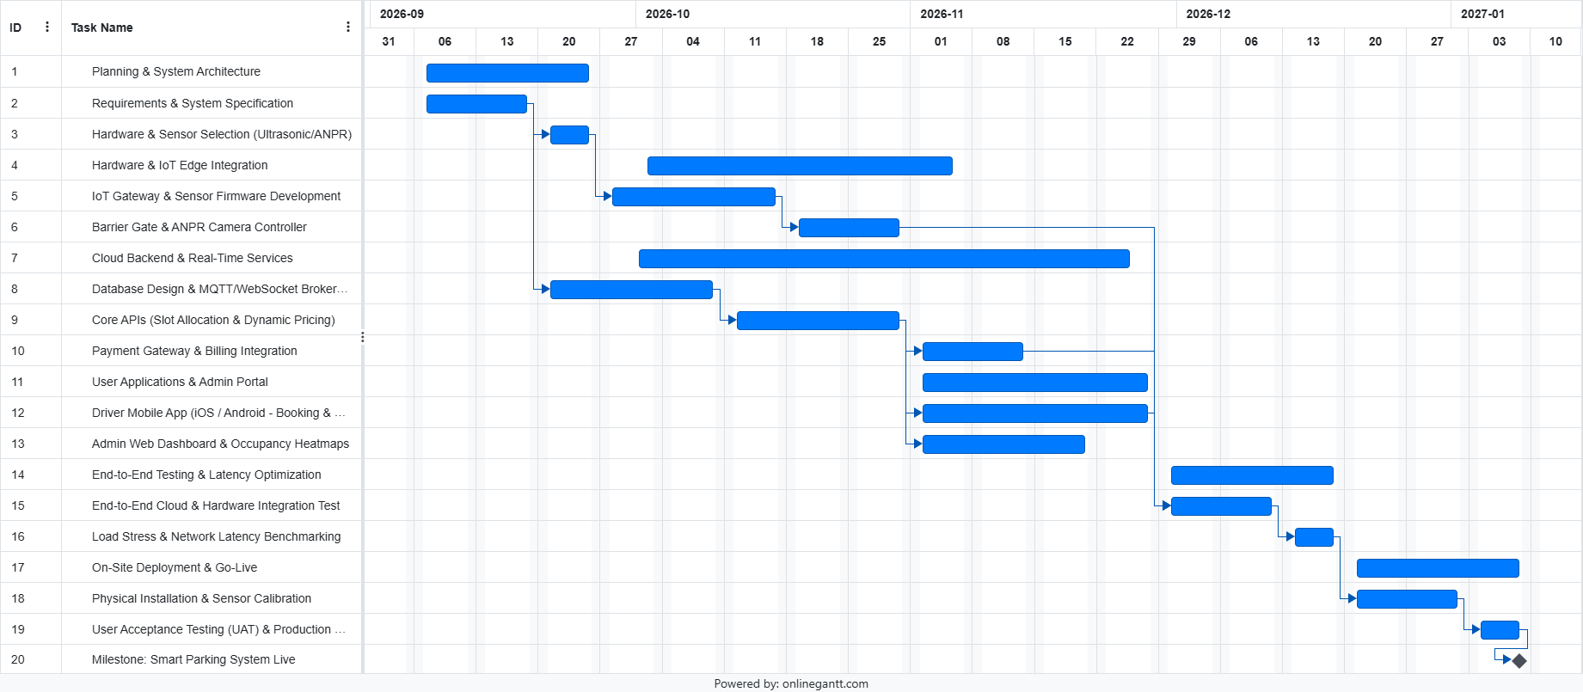
  - Identifies schedule slippages early, allowing project managers to apply fast-tracking or crashing techniques before deadlines are breached.

Conclusion: The project schedule for the Smart Parking Management System (SPMS) was organized and mapped using an online project management tool. The 20 project tasks were organized across six WBS phases spanning September 2026 to January 2027. Through Gantt chart tracking and Critical Path analysis, hardware-software integration dependencies were defined to keep project execution aligned with the target deployment deadline.

